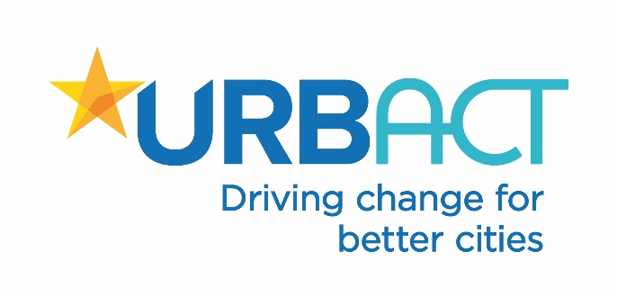

Application form
‘Playful Cities’ Transfer initiative
National Practice Transfer Initiative Ireland (NPTI)

Organisation details and proposed city/ town description

Name of the Local Authority

Is your council currently partner in an URBACT network or applying to join others? If yes which one(s)?

Contact details in relation to this application

Name and short description of the town/city to be part of the initiative (e.g. population, main economic activities, why it is a good candidate for inclusion)

What experiences or actions that has your council already implemented to allow opportunities for play and/or healthy placemaking within this town?

Local coordinator and people involved

Human resources available
What section or organisation will coordinate this initiative in your town/city?

Please indicate the staffing resources you can provide for your participation on the NPTI

Interagency structures

Please list the interagency structures in your county that can support the NPTI (e.g. Sports Partnerships, LCDCs, Healthy Cities & Counties, Age Friendly Cities & Counties, Mobility Forums, Environmental interagency groups, CYPSCs, etc.)

Local Stakeholders

Which local stakeholders do you anticipate involving in a URBACT Local Group (e.g. community groups, NGOs, local committees, action groups, etc.) to ensure a participatory approach and the successful transfer of the Good Practice?

Political and administrative support for participation in the Initiative

Please indicate the level of political support from the Mayor/Cathaoirleach and/or elected officials to participate in this initiative.

Please indicate the level support from the Chief Executive and/or relevant division heads to participate in this initiative (e.g. willingness to mobilise resources, disseminate results, integrate successful outcomes into future policy).

Please attach a letter of commitment to participate with your application form.

Added value – how the practice helps you achieve your policy goals

How do you think the Good Practice will provide benefits/solutions for your local context?

Please list the likely barriers at local level to transfer the Good Practice?

Please list the likely enablers at local level to the transfer of the Good Practice?

How will the implementation of the Good Practice serve, support or enhance council policies?

How will the implementation of the Good Practice serve, support or enhance your council’s contribution to other government policies and initiatives?

Capacity to communicate and build impact

Please describe the local communication channels and resources that you will use to communicate the practice and disseminate outcomes.

Please describe any relevant wider networks your council can leverage and/or feed into to communicate the outcomes of the practice and build lasting impact (e.g. Healthy Cities or County groups, Tidy Towns, men’s sheds, practitioner associations, etc.)

