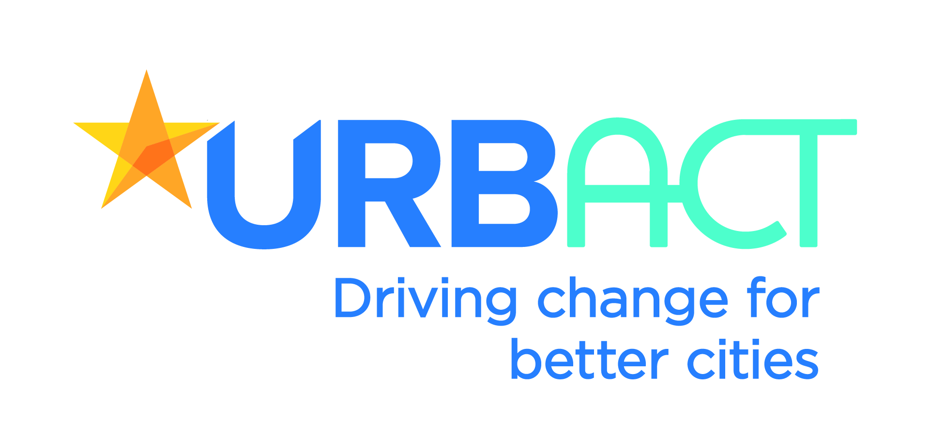
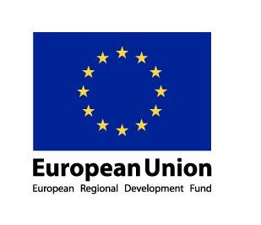

Terms of reference
CALL FOR PROPOSALS FOR NATIONAL PRACTICE TRANSFER INITIATIVE

Deadline to apply: May 9th 2021

April 2021

TABLE OF CONTENTS

OBJECTIVE OF THIS CALL 3
SECTION 1- BENEFITS FOR PARTICIPATING CITIES 3
SECTION 2- WHO SHOULD APPLY TO THIS CALL 3
SECTION 3 –WHO ARE THE MAIN BENEFICIARIES 4
SECTION 4 – The Playful Cities Practice 4
SECTION 4 – EXPECTED ACTIVITIES AND OUTPUTS 4
SECTION 5 – OTHER PEOPLE INVOLVED 5
SECTION 6 – FUNDING: WHAT’S COVERED 5
SECTION 7 - THE PROCESS TO SET UP A NATIONAL PRACTICE TRANSFER INITIATIVE 6
SECTION 8 – ASSSESSMENT CRITERIA 6

OBJECTIVE OF THIS CALL
On 9 March 2021, the URBACT Monitoring Committee has approved the testing of five National Practice Transfer initiatives across Europe.
A national practice transfer initiative aims to transfer a good practice, transferred, adapted, or developed by a transfer city under an URBACT III transfer network, to non-URBACT cities, at national level. The initiatives will start activities in June 2021, finish in December 2022 and be managed by the National URBACT Points.
For the Irish initiative, Cork was selected as the lead city for its successful implementation of the good practices from the Playful Paradigm transfer network. The Playful Paradigm network focused on “Introducing opportunities for play throughout the city for social, environmental and economic benefits”, and has been a great success in Cork.

This call aims to identify 5 to 7 cities interested in learning from Cork and transferring, adapting and implementing the practices of Playful Paradigm into their local contexts from June 2021 to December 2022.

The selected city administrations will commit to:
- identify at least a project coordinator to follow all the activities foreseen below,
- set up a group of local stakeholders to facilitate the transfer, adaptation and implementation of the good practice,
- participate and host meetings when necessary, and liaise with the transfer city, National URBACT Point and other relevant stakeholders.
In return, they will benefit from the URBACT method to design integrated and participatory policies, including exchange and learning activities, expertise, trainings, guidance as presented below.

SECTION 1- BENEFITS FOR PARTICIPATING CITIES
Throughout the URBACT national practice transfer initiative, participating cities will benefit from expertise, guidance, and know-how from the transfer city, national expert, National URBACT Point and URBACT Secretariat when necessary. Travel and accommodation costs of participating cities to meetings and study visits will be covered by the National URBACT Point.

Expected results for participating cities would be:
- Local positive change in promoting placemaking and activation of public spaces to increase the attractiveness of our urban centres.
- Increased understanding and implementation of participatory and integrated policy-making and learning from other Irish towns and cities.
- Strengthened skills of involved people in bringing communities together to co-create and deliver play activities in public spaces
- Increased capacity to participate in URBACT and other European programmes

SECTION 2- WHO SHOULD APPLY TO THIS CALL
Only cities that have not participated in phase 2 of URBACT III networks are eligible to participate. This means that the following towns and cities are ineligible:

Athy, Balbriggan, Cork, Dublin, Dún Laoghaire-Rathdown, Kilkenny, Limerick, Longford, Monaghan, Naas, Waterford

However, public local authorities who have previously participated in phase 2 of URBACT III networks are eligible to participate if the proposed beneficiary city is not included in the list above.

Under URBACT III, the beneficiary “city” refers to the public local authority representing:

Cities, municipalities, towns:
Infra-municipal tiers of government such as city districts and boroughs in cases where they are represented by a politico-administrative institution having competences for policy-making and implementation in the policy area covered by the national practice transfer initiative.

Plus non-city partners:
Local agencies defined as public or semi-public organisations set up by a city, partially or fully owned by the city authority, responsible for the design and implementation of specific policies (economic development, energy supply, health services, transport, etc.)

There is no limit of size (population) for cities wishing to participate in URBACT activities.

SECTION 3 –WHO ARE THE MAIN BENEFICIARIES
  - URBACT Transfer city
This is the city of Cork that has participated in the URBACT Playful Paradigm network. This city has already committed to share their good practice and accompany participating cities in their transfer process. Cork will participate in all activities set in a common methodology/roadmap with the participating cities. Cork will also explore how to further improve its good practice implementation.
  - Participating cities
These will be 5 to 7 non-URBACT III cities eager to transfer/adapt the plans/process of the good practice city. They will commit to participate in all meetings and activities (study visits, peer reviews, online meetings, plans, reports, etc). Each of these cities, will have to set up an URBACT local group, prepare transfer plans, and ideally start the implementation of the good practice within the 18 months of the initiative.

SECTION 4 – The Playful Cities Practice
The Playful Cities practice was developed under the URBACT Transfer Network Playful Paradigm, and has been successfully implemented into Cork city.

The elements of the practice are modular, i.e. towns and cities can implement as few or as many of the practices, and at a variety of scales, as their inclination and resources allow.

The practice aims to increase the opportunities for play throughout a city and is based on the use of “games” for promoting social inclusion, healthy lifestyles, place-making and economic prosperity. It has the potential to have a positive effect in terms of its social, economic, environmental impacts; by bringing people and communities together to explore play in a different and creative way, often in places that are made safe for play, for example by reducing traffic and improving air quality in neighbourhood streets and school streets, and providing new and enhanced experiences in our public spaces to revitalise towns and cities.

The Covid19 pandemic together with the city’s involvement in the Playful Paradigm Project has brought a renewed focus on outdoor recreational activities in public spaces and opportunities to transform local public spaces into play places during community events and city festivals.

SECTION 4 – EXPECTED ACTIVITIES AND OUTPUTS
Expected outputs per participating city include at least:
- Transferability analysis for all participating cities produced by the national expert (including SWOT analysis and recommendations) in the first months of this initiative and prior to the cities’ transfer plans

- A transfer plan- developed early on in the transfer process that would detail how the good practice will be adapted/implemented to each participating city

- Set up an URBACT local group in each participating city

- Attendance & participation in initiative meetings (quarterly) and training sessions (2)

- Some actions of the transfer plan to be implemented by the end of December 2022

In addition, within this initiative the following outputs will be produced:

- Articles about the work and results of cities produced by the cities, National URBACT Point and experts.

SECTION 5 – OTHER PEOPLE INVOLVED

National URBACT Point (Dr Mike Brennan, Eastern and Midland Regional Assembly): will be responsible for managing the initiative at national level in addition to their existing duties. National URBACT Points acting as national coordinators will be responsible for supervising, implementing the initiative, and for reporting to the URBACT Secretariat and members of the URBACT Monitoring Committee when relevant.

National expert: They should be an expert on the topic of the transfer city that would accompany all the cities in the transfer process. They should be in charge of preparing/facilitating the meetings in terms of content and exchanges, preparing documents and guidance, elaborating the transferability analyses, commenting the transfer plans, and following up the transfer process in each city.

URBACT Monitoring Committee member (Pauline Riordan, Eastern and Midland Regional Assembly): the member of the URBACT Monitoring Committee (MC) will be in close contact with the National URBACT Point who will inform when necessary about progress of the exchanges and transfer. The MC member will also be involved in the selection process of the transfer city and other participating cities. They will be invited to participate in exchanges between cities and when necessary inform the rest of the URBACT Monitoring Committee members about the national experience.

URBACT Secretariat: will coordinate the five national practice transfer initiatives across countries. The URBACT Secretariat will organise online trainings/meetings for national experts, National URBACT Points, and participating cities when relevant.

SECTION 6 – FUNDING: WHAT’S COVERED
As with all URBACT networks, direct staff costs are not covered for participating cities, however Playful Paradigm offers an opportunity to learn from experts in the field of play and funding can be used for transfer meetings, study visits and engaging with national experts to build capacity in towns and cities.
The National Practice Transfer Initiative funding will cover
- Travel and subsistence costs for staff of all the participating cities, national experts, external speakers, and of the staff of the NUP organisation that relate to delivery of the initiative. This category includes travel costs, accommodation costs, costs of meals, and/or daily allowances/per diems if relevant.

- Venue rent/catering costs related to the organisation of meetings hosted by a participating city of this initiative. It covers renting a venue to accommodate the meeting with the necessary technical material, and catering expenses.

- Equipment costs for equipment, digital software and tools purchased by the National URBACT Points for the purposes of this initiative.

SECTION 7 - THE PROCESS TO SET UP A NATIONAL PRACTICE TRANSFER INITIATIVE
7.1 Applying: A completed application form and signed letters of commitment must be received by May 9th@ 17:00. Links can be found for

- The application form (Link here)
- The letter for commitment (Link here)

Completed forms should be sent to mbrennan@emra.ie with the subject line NPTI Application.

7.2. Assessment: Applications will be assessed by the National URBACT Point and the URBACT PMC member in consultation with the URBACT Transfer City (Cork)

7.3. Official start and end: The National Practice Transfer will start on 1st June 2021 and finish by December 2022.

SECTION 8 – ASSSESSMENT CRITERIA
All submitted proposals will be assessed on the following criteria. Each criterion will be assessed with points. The maximum number of points a criterion can receive is presented below.
Criterion A – Local coordinator and people involved - 30 points
For this criterion, the following dimensions will be considered:

  - Relevance of people from the city administration involved in this initiative
  - Time to be spent in this initiative
  - Coordinator’s experience in engaging with different stakeholders, organising events, facilitating discussions, project management
  - Potential for local stakeholders to participate in co-creating local activities

Criterion B – Political and administrative support - 20 points
For this criterion, the following dimension will be considered:
- Mayor/Cathaoirleach and/or elected officials will be sufficiently supportive in this initiative and facilitate the transfer/adaptation process
- Chief Executive and/or relevant division heads will support the activities and implementation of the initiative
Criterion C – Added value - 30 points
For this criterion, the following dimensions will be considered:

  - The local situation necessitates new or additional actions in relation to the topic of the national practice transfer initiative
  - The national practice transfer initiative will clearly serve or feed in local strategies/objectives or priorities
  - The national practice transfer initiative will support regional / national strategic outcomes and policy making
Criterion D – Communication capacity and Impact –20 points
For this criterion, the following dimensions will be considered:
- The city has the relevant communication resources and means to communicate on this initiative
- Potential to leverage and/or feed into relevant stakeholder and communication networks at a wider scale and build lasting impact.

